**Deliverables Nicolas Mori**

Index:

1. A quick write up of your experience
2. A screen shot showing you inspecting the application with Appium’s inspector
3. Source code, including page objects and locators, supporting the 1 running scenario.

* **1/3, A quick write up of your experience**

5 years of exterience working in Automation with selenium, and 3 years of experience working with Appium, at this moment I make automation code with Java, and I write frameworks with Page Object pattern and with DSL (Domain-specific language) for make automation in parallel devices. I use for that Cucumber, TestNG, Appium, Maven, Selenium and Java.

Right now I am working for integrate the parallel automations in Android and IOS. The objetive for this year is complete all the framework for execute in parallel, devices IOS, devices Android and Web App, all working from Jenkins, and with the pattern DSL, from créate the actions or methods 1 time and use that for all the differents devices.

In my video portfolio of 1.30 minutes, you can see, parallel Android execution, and parallel IOS execution.

Example of IPhone Paralell.

<https://www.youtube.com/watch?v=aQqPVYoymRs>

Example of Android Paralell.

<https://www.youtube.com/watch?v=3eCaEFEgZcI>

* **2/3, A screen shot showing you inspecting the application with Appium’s inspector**

Image 1/3, Appium setup.

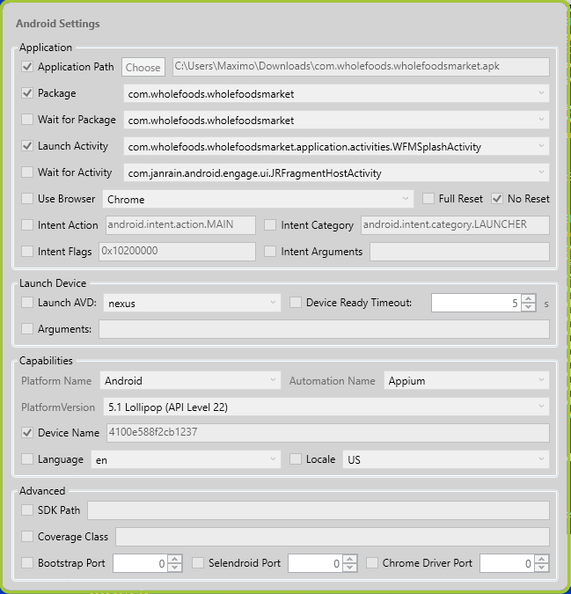

Image 2/3, Appium Inspector,

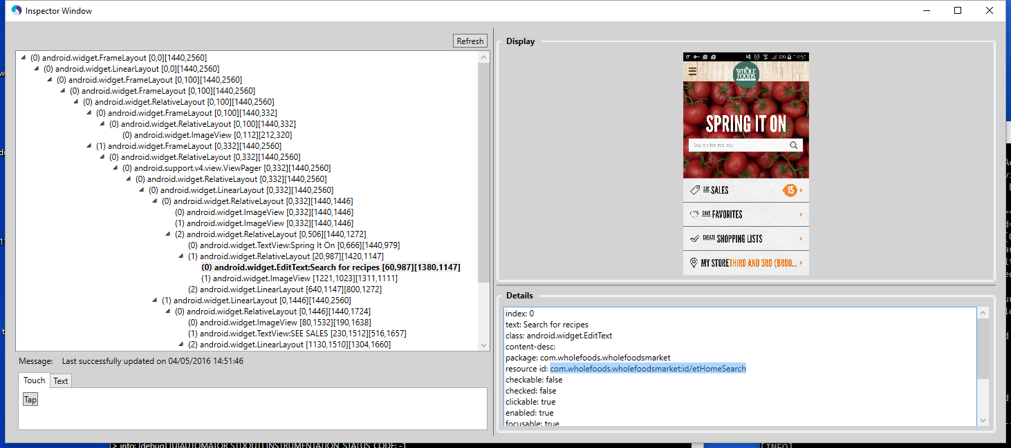

Image 3/3, UiAutomator,

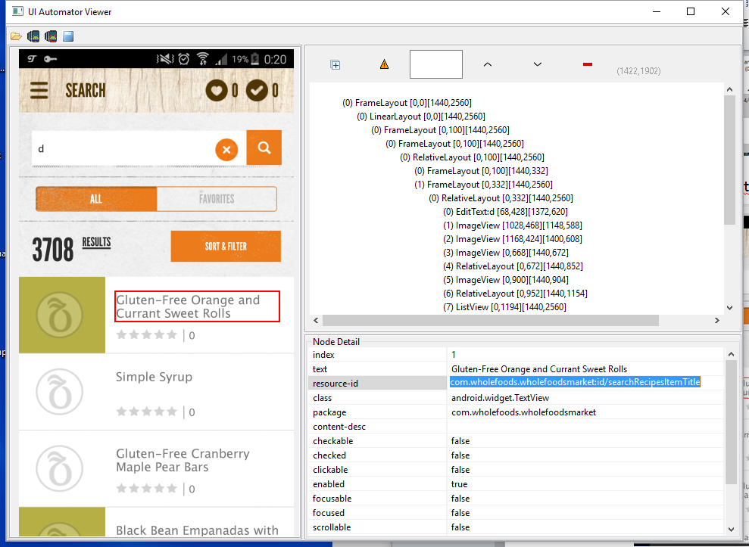

* **3/3, Source code, including page objects and locators, supporting the 1 running scenario.**

Github url:

https://github.com/nicomori/Applause_Exercise_Nicolas_Mori.git

Command for execute:

mvn clean compile test -DsuiteFile=run-bvt.xml -Dgroups=reg-device -Dbrowser=LOCAL_ANDROID_MOBILE -DtakeSnapShots=true -DappActivity=com.wholefoods.wholefoodsmarket.application.activities.WFMSplashActivity -DappPackage=com.wholefoods.wholefoodsmarket -DsnapshotDirectory=com.wholefoods.wholefoodsmarket.apk